**eProject’s Description**

Project’s name: BagBag

Members of our team:

1. Student1358713: ANH NGUYEN VIET
2. Student1358712: THANG NGUYEN QUANG
3. Student1358711: CHINH NGUYEN VAN

*Hello eProjects team,*

We have finished the project that you gave us. Here is the description for the project that could show you how to use our web.

First, we have the home-page, the main website of our project.

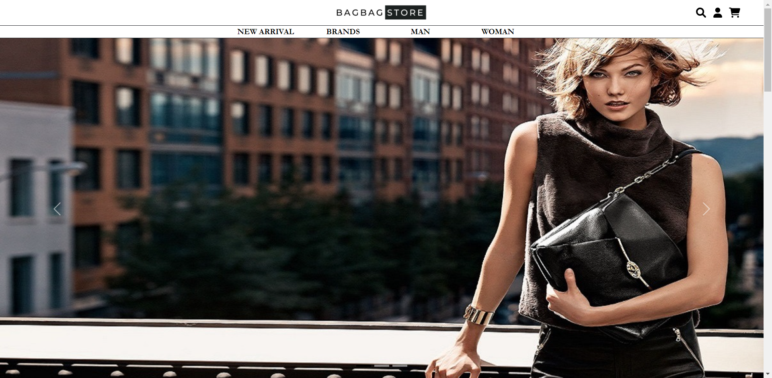

At this site, you can see the logo and the menu-bar at the top of its.

* You can access to home-page at any site of the project by clicking on the the logo at the top of the web.
* On the right of the logo-bar, you can see there are three icons that you can interact with:

Search icon: if you want to find anything, all you had to do is clicking on the search icon and type what you want on the search bar which was appear on the left-side of the icon then leave the rest for us.

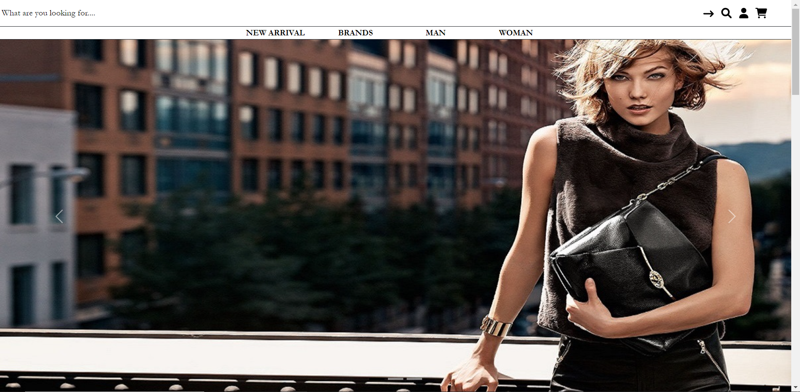

* Next to it, you can see the account-icon, which can help you to access to your account. We will talk more about this in the next section. (1)
* And the last one is the cart-icon. By clicking on this, you will go directly to the payment, the ones that would be discussion later. (2)

Right down below, we have the navbar menu. We have 4 options: New Arrival, Brands, Man and Woman.

* New Arrival: show you our new stuff. You would go directly to the main web when click on this.
* Brands: include a lot of famous brands like Chlóe, Coach, Dior…. We have a separate website for each brands that we have. You can click to the brand you like to access it. (3)
* Man: man’s bags, of course. (4)
* Woman: it’s about woman’s bags, doesn’t need to say too much about this, right. (5)

That’s the header of the website. Now let’s go to the body.

First, we have a slide showing our variety type of bags.

Second, right down below, is the new products list.

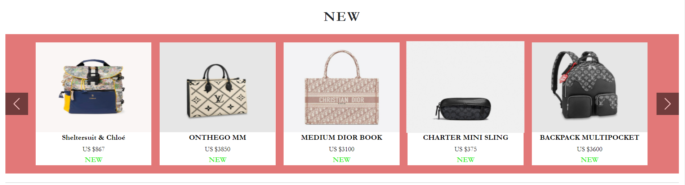

We created it with slide so you can see more type of bags at this. You can see the detail of each product by clicking on it.

The next ones is about the type of bags that we have: Cross body, sling bags, tote bags and backpacks. (6)

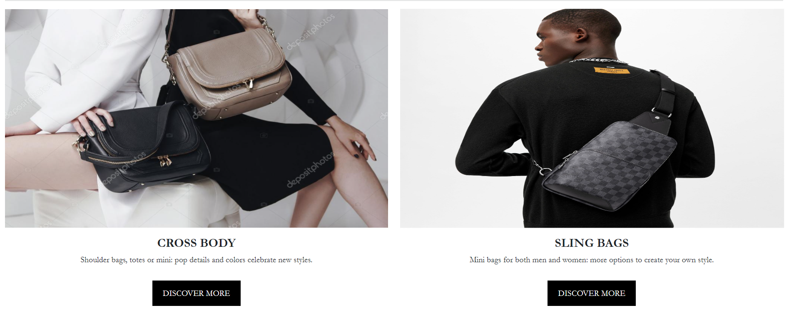

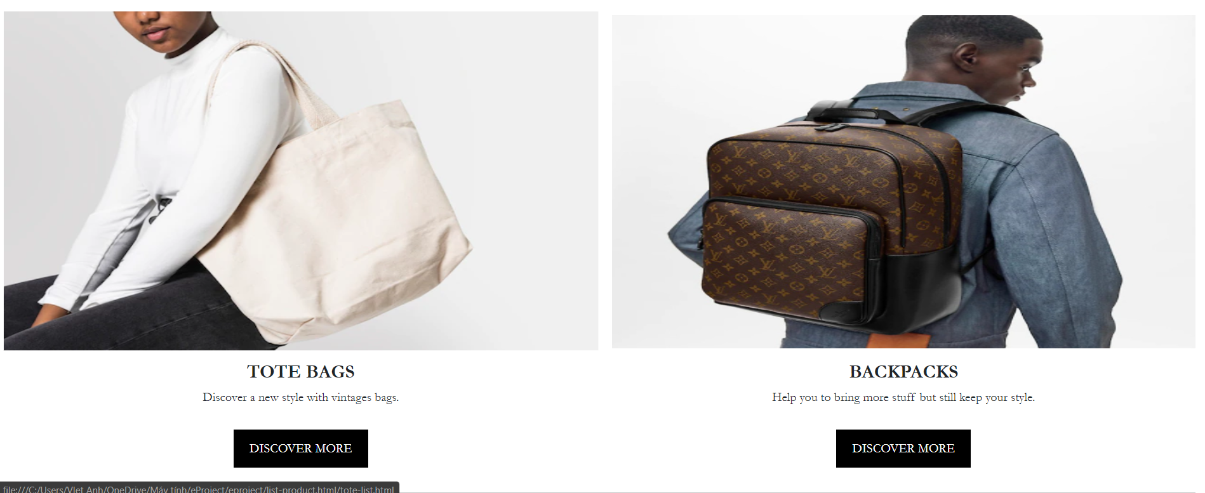

In order to earned the trust from customer, we were created a section that customer can see and send feedback for our website which can help us to change for better. (7)

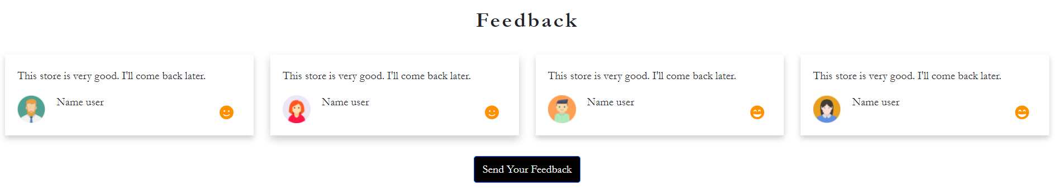

And the last of the body, for the commercial purposes, the Advertise section.

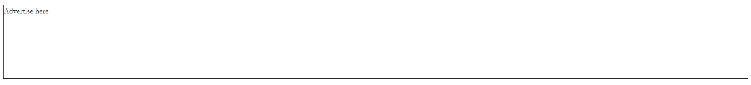

The website’s ending is the footer. At this section, you can see the informations about us, our stores and how to contact us.

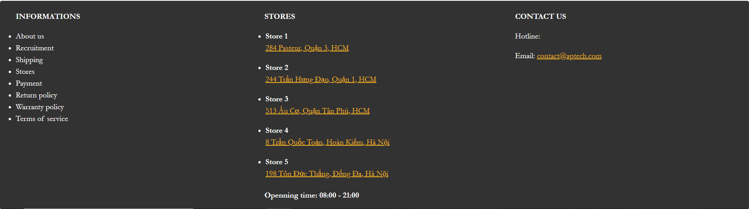

Now let’s go to the detail of our website.

(1). Account- icon:

By understanding how much important you are to us, we would love to show you how much we care about you – our beloved customer. By creating an account at our website, you can received our new updates and discount.

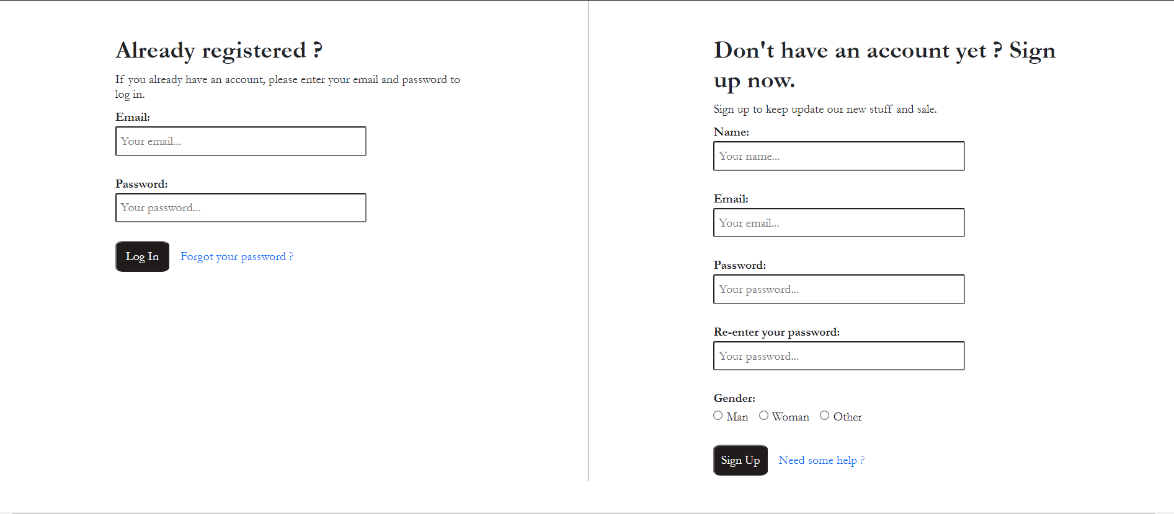

Well, people make mistake sometimes, so we could understand that you could forgot your password. Don’t worry because we can help you to recover your password. First, we need you to click on “Forgot your password ?” section to go to the recover password page.

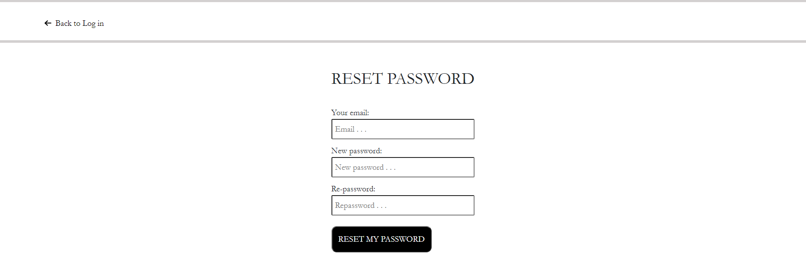

Now you need to give us your informations so we could help you to reset your password.

(2). Cart-icon:

Like I said before, when click on the cart icon, you would go to the payment immediately.

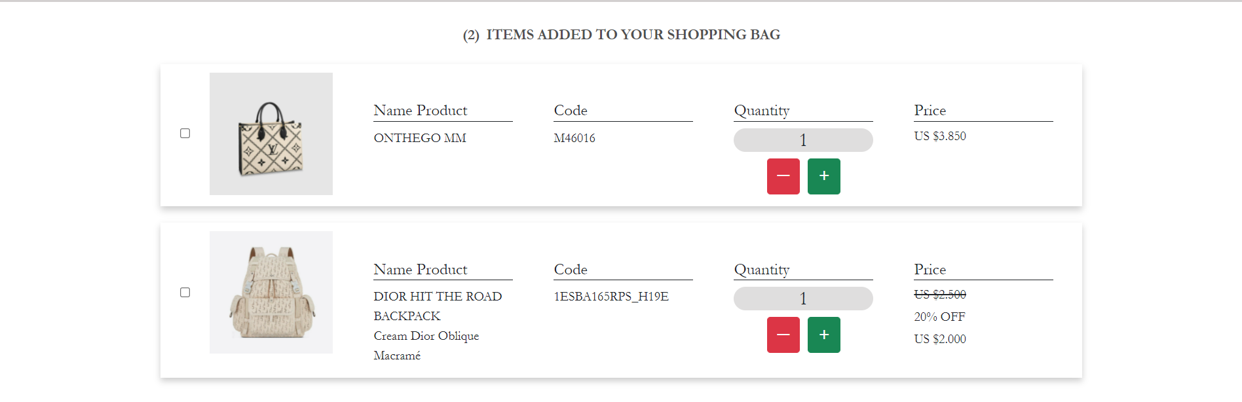

Here is the detail of your payment which include price, tax, shipping and the promotion code, of course.

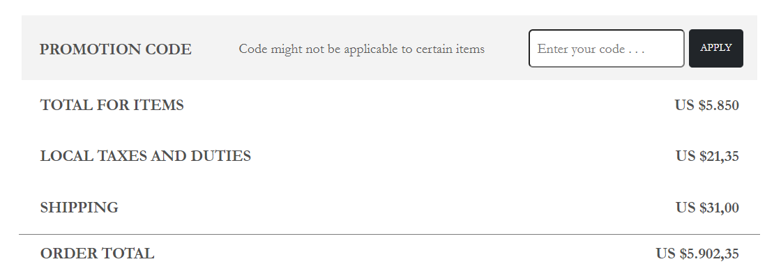

(4), (5). Man and Woman:

We use these sections to showing variety type of bags for man and woman. On the left-side of the page, you can see the filter which could help you to find some certain type of bags.

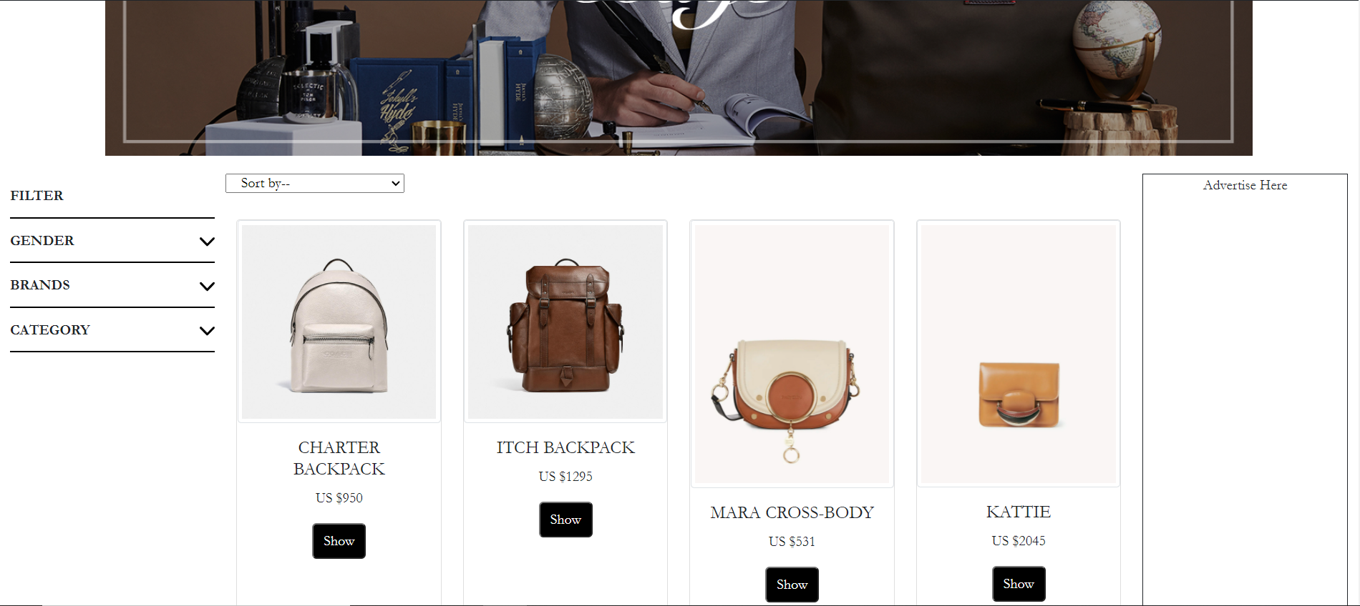

Oh yes, you can see the advertise section on the right-side, for the commercial pusposes, obviously.

(6). Our type of bags that we have:

we have 4 types of representative bags. You can see more option of each type by clicking on “discover more”, its will lead you to a new website instead. Here is an example:

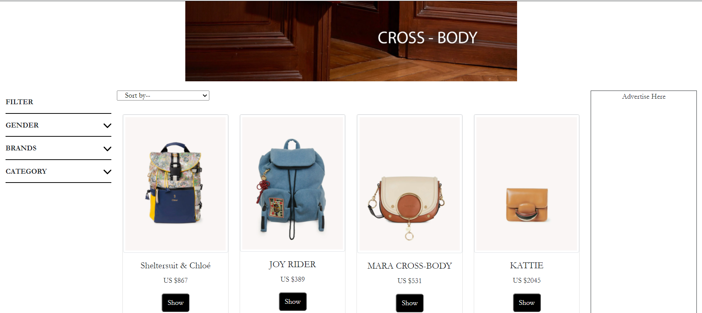

(4), (5), (6). Detail of each product:

As you can see, when you access to a site which showing our products, you can see a “show” button which would lead you to a new tab that will tell you more detail of that product. It is include name, price, description and the detail. You can check it out right away or send it to your cart and take another look on our website for more option.

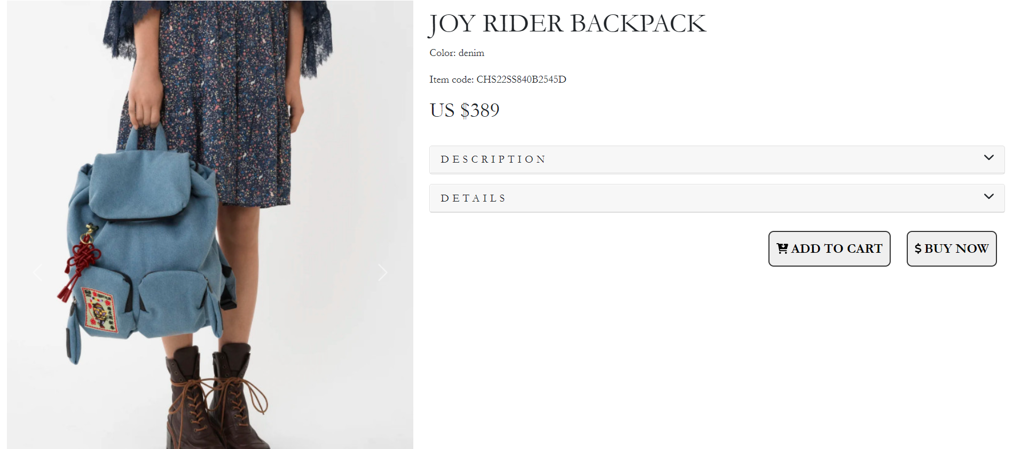

If you are wondering about how another think about this, you can read the comment down below or leave a comment/feedback of this product.

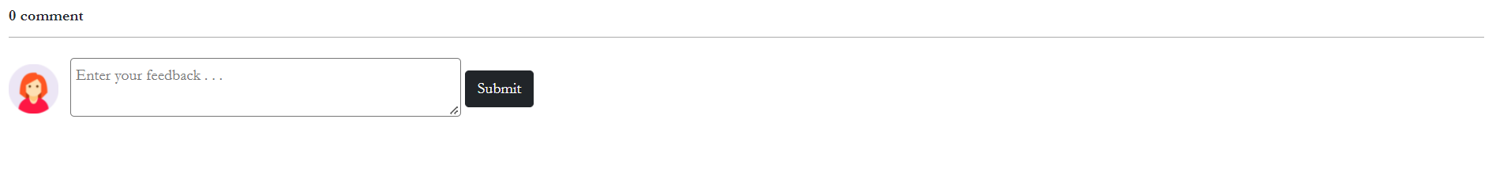

And the advertise section. Please don’t be upset because we are having too much adversite section, we need to living, too, wish you sympathize.

(7). Feedback:

“ Always listenning, always understanding. “

With the purpose of always developing to serve you in the best way, we always want to get all the feedback from our customer. You can tell us how you feel about our website, about our product quality, how good of our customer care…. Anything you want to say that could help us to improve, we are always ready to listen.

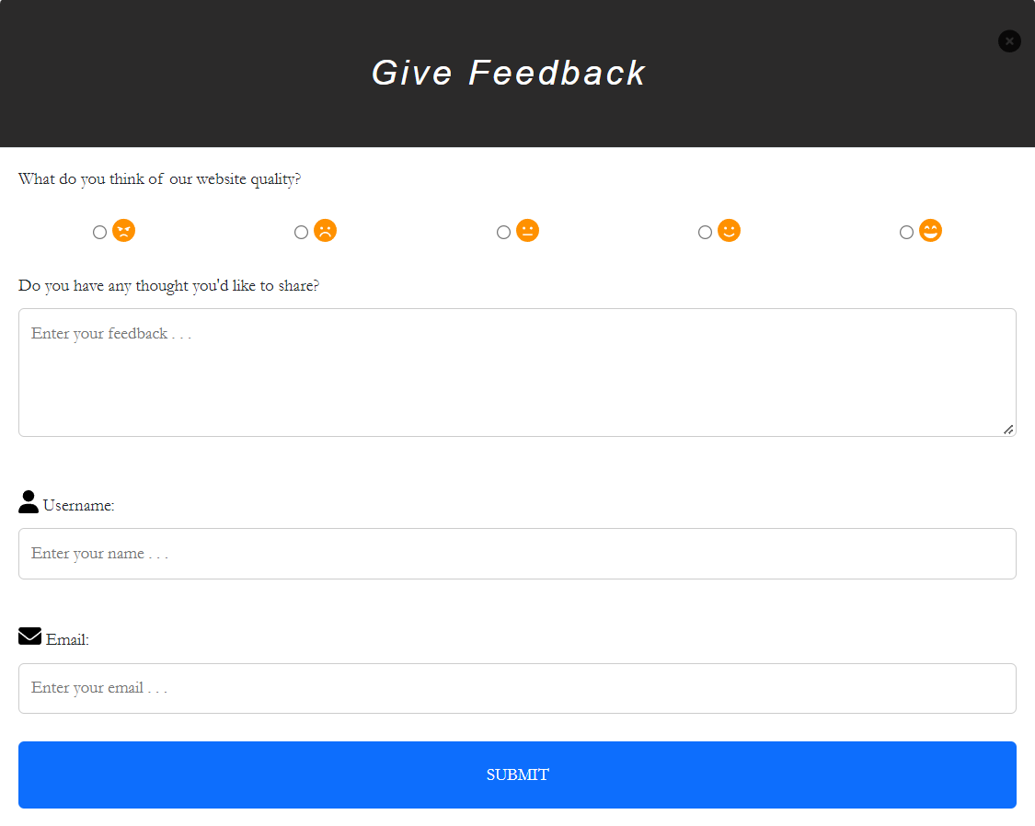

It doesn’t matter if you gave us your informations or not, we understand that for some reasons you don’t want to reveal yourself.

So, it is the full of description how to using our website. The description about code is inside the HTML and CSS in the comment form. Thanks for reading.

***Best regards,***

***Viet Anh Nguyen.***